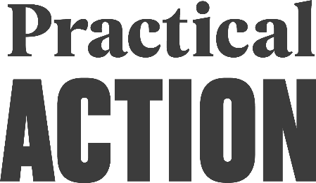 **Practical Action**

Job profile

COUNTRY MANAGER-RWANDA MATERNITY COVER, 6 MONTHS

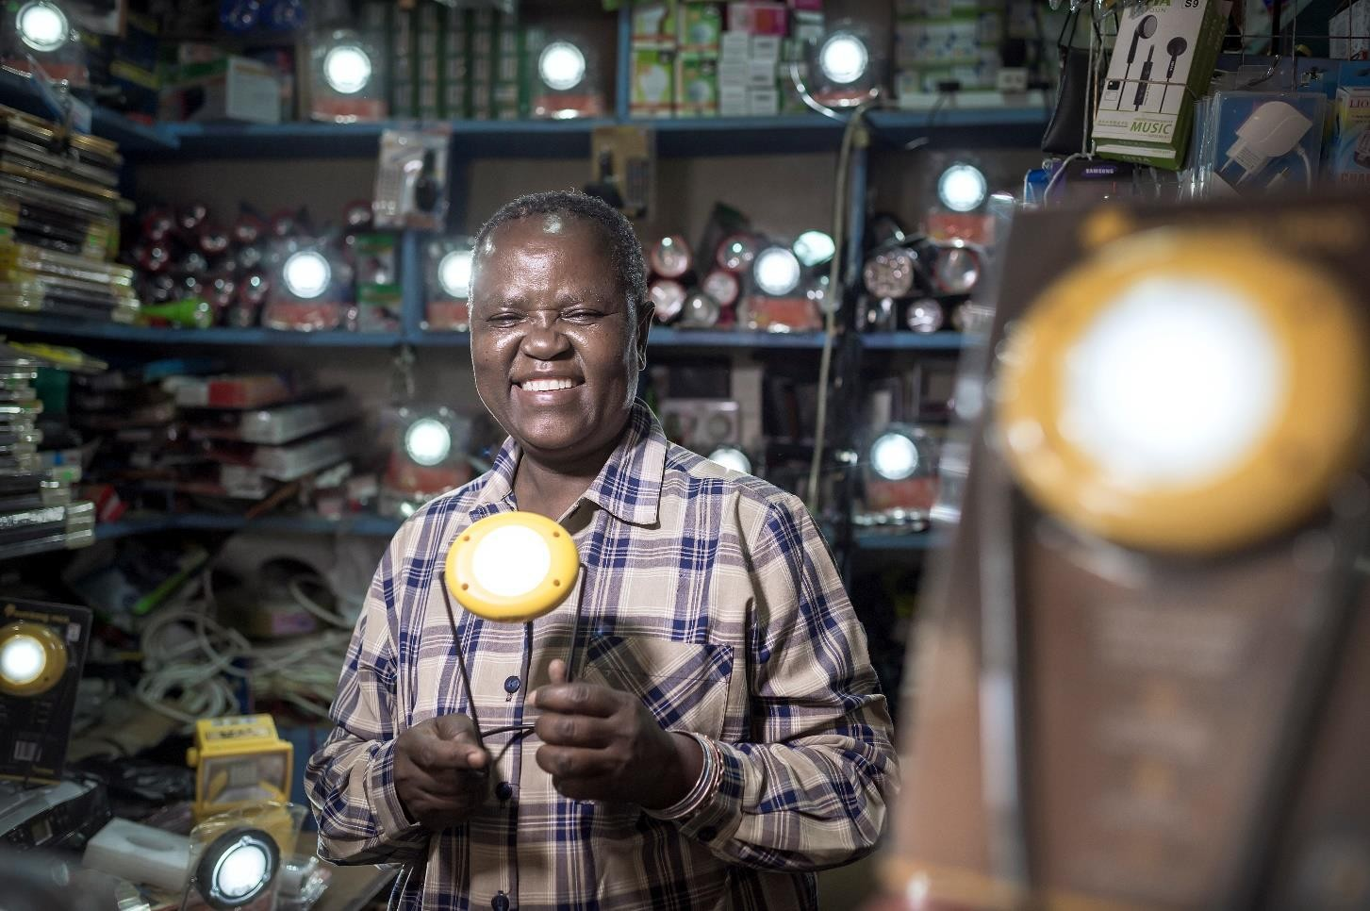

ABOUT US

We are an international development organization putting ingenious ideas to work so people in poverty can change their world.

We help people find solutions to some of the world’s toughest problems. Challenges made worse by catastrophic climate change and persistent gender inequality. We work with communities to develop ingenious, lasting and locally owned solutions for agriculture, water and waste management, climate resilience and clean energy. And we share what works with others, so answers that start small can grow big.

We’re a global change-making group. The group consists of a UK registered charity with community projects in Africa, Asia and Latin America, an independent development publishing company and a technical consulting service. We combine these specialisms to multiply our impact and help shape a world that works better for everyone.

**OUR AIMS**

We help people find solutions to some of the world’s toughest problems, made worse by catastrophic climate change and persistent gender inequality. Our aims are to:

* Make agriculture work better for smallholder farmers, many of them women, so they can adapt to climate change and achieve a good standard of living
* Help more people harness the transformational effects of clean affordable energy and reduce avoidable deaths caused by smoke from indoor stoves and fires.
* Make cities in poorer countries cleaner, healthier places to live and work.
* Build disaster resilience into the lives of people threatened by hazards – reducing the risk of hazards and minimizing their impact on lives and livelihoods.

**PRACTICAL ACTION IN EAST AFRICA**

In East Africa, Practical Action has a long history of addressing systemic barriers that prevent people from accessing energy that transforms their lives, helping communities and government make cities healthier and safer, making agriculture and markets work better for small holder farmers and supporting communities and government to become more resilient.

We use a mix of programming with communities and consultancy services with shapers of policy and practice to achieve our aims in Kenya, Rwanda, Uganda and Tanzania with offices in Nairobi, Kigali, Lodwar and Kisumu.

In **Rwanda**, we are recognized leaders in clean cooking and sustainable energy solutions. This includes ground-breaking work in solar, wind and water powered electricity generation, often delivered through independent mini-grids. We bring rural communities, people in refugee camps, energy providers and decision makers together to put sustainable, clean energy solutions to work for the people who need them most.

In our strategic business plan 2018-2021, we propose to extend our current reach and scope in Rwanda by deepening our energy work and stretching our portfolio to work with small holder farmers to make agriculture work better for them.

**Practical Action**

ABOUT THE ROLE

The Country Manager, Rwanda, is an instrumental position within Practical Action’s East Africa structure. This person has overall leadership of the field office and provides effective steer to the delivery and development of programs in his/her area of operations.

The Country Manager is responsible for the efficient management of the field office resources (grants, awards, staff and assets) and leads the representation of Practical Action with Country level authorities, INGOs and NGOS, and visitors.

His/her management of programme implementation and operations will ensure that the Field Office is in accordance with Practical Action policies and practises its Mission, Vision and Values.

**SCOPE**

|  |  |
| --- | --- |
| **Title** | Country Manager - Rwanda |
| **Reporting to** | Regional Director, East Africa |
| **Direct reports** | RE4R Project Coordinator  Senior MEL Officer  HR Officer  Finance Officer Procurement Officer  Office Assistant/ Receptionist TREYL Project Officer ( Potential) |
| **Relationships** | Externally with strategic partners and internally with colleagues in  the UK and global offices, technical advisors, support teams and the impact team. |
| **Financial scope** | TBC |
| **Location** | Kigali, Rwanda |
| **Grade** |  |
| **Travel** | Within scope |

**ACCOUNTABILITIES**

**Leadership and Strategic Alignment**

* Lead annual plans for Rwanda including development of area budgets and sub plans to Practical Action’s internal Key Performance Indicators (KPIs).
* Lead Rwanda quarterly and annual reporting against the Strategic Business Plan (SBP), particularly working with RMT on risk management.
* Ensure that project activities, outputs and outcomes feed into Practical Action’s impact ambition and strategic plans.
* Lead, manage and motivate a team of field staff, ensuring that they have clear work objectives and individual/team work plans and receive meaningful feedback on their performance.
* In coordination with the Regional Management Team (RMT), maintain appropriate staffing levels and structures in the area team, whilst planning and implementing specific actions to recruit, manage and motivate staff.
* Ensure appropriate gender and ethnic diversity within the area team.
* Ensure compliance with staff development strategies and Performance Management systems and evaluations.

**Strengthening Profile, Generating Funding and Managing Relationships**

* Ensure that the required approvals and mode of engagement are maintained with local government and partners including necessary MOUs and authorization to work in Rwanda.
* Establish, maintain, and improve active and regular working relationships and take the lead role in representing the principles and work of Practical Action to representatives of other organizations who are working and visiting in the area
* Oversee that local implementing partners are discharging their responsibilities, live up to stipulations stated in the partnership agreement and take appropriate action.
* Lead the strategy and proposal development within the area under the overall leadership of the fundraising team.
* Responsible for ensuring that proposals are relevant, contextualized and inclusive of all required support and staffing costs at the field level.

**Delivering Quality**

* Responsible and accountable for Practical Action’s projects in the country and ensure the planning, implementation and management of programs are in accordance with the organization’s strategies and policies.
* Lead the field office support team in ensuring the smooth day-to-day running of field operations and ensure that program plans are clearly prioritized and communicated across the organization.
* Conduct regular area team meetings to enhance information sharing among area staff and effectiveness of operations.
* Work closely with the team in Nairobi to ensure adequate operational support to deliver high quality programs effectively.
* Lead the development and monitoring of field-based detailed programme implementation and grant management work plans.
* Responsible for ensuring that field-based teams implement programs on schedule and within budget.
* Responsible for the delivery of high quality, timely reports for donors and internal purposes, as well as the development of relevant case studies, success stories and other documentation.
* Lead field-based kick off meetings of new projects with relevant Regional/Country Office (RCO) staff to guarantee a joint understanding among team members of donor requirements, budget responsibilities, technical requirements and other considerations.
* Ensure standardized systems, policies and procedures are in place, well understood by all staff and in line with the organizations systems and are implemented in an appropriate manner.
* Ensure that the principles of safeguarding are embedded in all project planning, implementation and reporting and that staff receive regular, up to date training on same.
* Ensure transparency in targeting beneficiaries, delivery of services and participation of beneficiaries and partners in planning and monitoring of process is reflected in program delivery.
* Responsible for all budgets (donors and PA own resources) provided to the area. This may be delegated to other budget holders but overall accountability for the budgets for the area remains with the Area Lead.
* Participate in monthly budget holder meetings.
* Ensure timely report providing a variance analysis on each budget is submitted to the Regional Director.
* Identify any budget challenges or issues such as over or underspends and propose solutions to line manager as soon as issues are identified. Ensure that these are identified through the monthly budget holder meetings and immediately addressed.
* Prepare annual budgets for the Area Office, assessing costs and budget/expenditures from projects and asset inventory.

**PERSON PROFILE**

To be successful in the role, the ideal candidate will be able to demonstrate:

|  |  |
| --- | --- |
| **Experience & Knowledge**  **Essential**  **Desirable** | * Extensive experience in project management and working knowledge in one of Practical Action’s thematic area (climate resilience, agriculture, renewable energy, WASH & waste management). * Bachelor’s degree in development or other social sciences * Extensive practical senior management experience preferably in development programs. * Experience of managing the programme cycle, including assessments, project design, proposal and report writing, implementation, monitoring and evaluation * Strong results orientation, with the ability to challenge existing mind set * Experience of managing sizeable and diverse teams in resource- poor, insecure settings. * Excellent planning, coordination, and reporting skills, with the ability to organize a substantial workload comprised of complex, diverse tasks and responsibilities; * Strong analytical, monitoring and evaluation, and report- writing abilities; * Technical skills in one or more Practical Action sectors – Renewable Energy, Climate and Resilience, WASH and Waste Management, and Agriculture; * Strong, demonstrable, financial management skills, particularly in budgeting and reporting; * Experience in, and a commitment to, the implementation of robust Performance Management and staff capacity building and development. * Strong communication, people management and interpersonal skills in English and Kinyarwanda. * Computer literacy, particularly in Word, Excel, and PowerPoint * Strong representational and communication skills. * Fluency in other languages and local languages in Rwanda. * Existing strong relationships and networks within the geographic area. * Post-graduate degree in relevant subject. * Experience in working in remote areas and with rural communities. |