

Job profile

Re4r Project Coordinator – rwanda

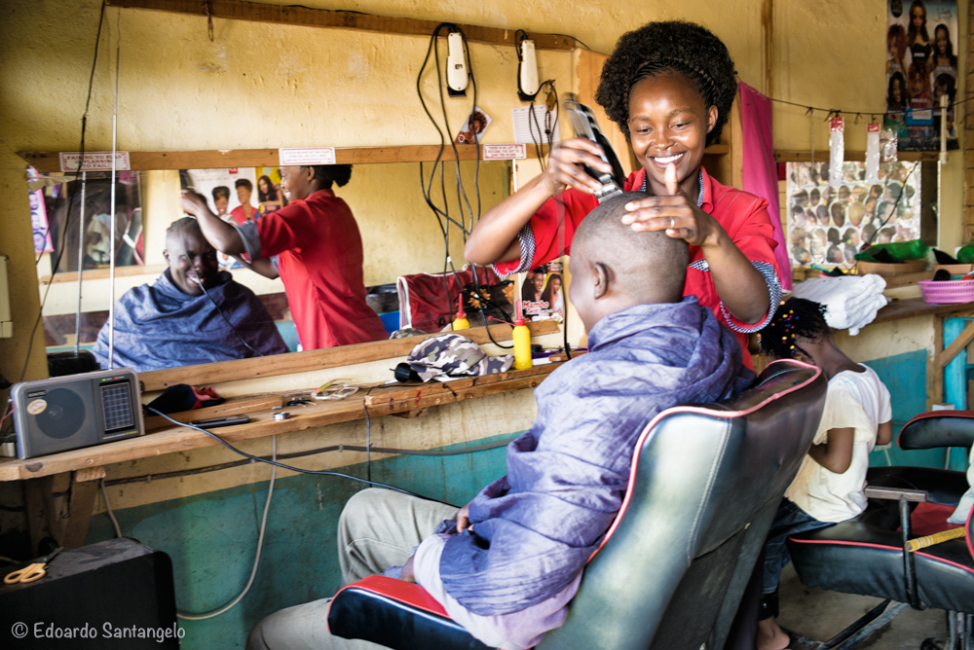

Practical Action

about us

We are an international development organisation putting ingenious ideas to work so people in poverty can change their world.

We help people find solutions to some of the world’s toughest problems. Challenges made worse by catastrophic climate change and persistent gender inequality. We work with communities to develop ingenious, lasting and locally owned solutions for agriculture, water and waste management, climate resilience and clean energy. And we share what works with others, so answers that start small can grow big.

We’re a global change-making group. The group consists of a UK registered charity with community projects in Africa, Asia and Latin America, an independent development publishing company and a technical consulting service. We combine these specialisms to multiply our impact and help shape a world that works better for everyone.

**OUR AIMS**

We help people find solutions to some of the world’s toughest problems, made worse by catastrophic climate change and persistent gender inequality. Our aims are to:

* Make agriculture work better for smallholder farmers, many of them women, so they can adapt to climate change and achieve a good standard of living
* Help more people harness the transformational effects of clean affordable energy and reduce avoidable deaths caused by smoke from indoor stoves and fires.
* Make cities in poorer countries cleaner, healthier places to live and work.
* Build disaster resilience into the lives of people threatened by hazards – reducing the risk of hazards and minimizing their impact on lives and livelihoods.

**PRACTICAL ACTION IN EAST AFRICA**

In East Africa, Practical Action has a long history of addressing systemic barriers that prevent people from accessing energy that transforms their lives, helping communities and government make cities healthier and safer, making agriculture and markets work better for small holder farmers and supporting communities and government to become more resilient.

We use a mix of programming with communities and consultancy services with shapers of policy and practice to achieve our aims in Kenya, Rwanda, Uganda and Tanzania with offices in Nairobi, Kigali, Lodwar and Kisumu.

In **Rwanda**, we are recognized leaders in clean cooking and sustainable energy solutions. This includes ground-breaking work in solar, wind and water powered electricity generation, often delivered through independent mini-grids. We bring rural communities, people in refugee camps, energy providers and decision makers together to put sustainable, clean energy solutions to work for the people who need them most.

In our strategic business plan 2021-2025, we propose to extend our current reach and scope in Rwanda by deepening our energy work and stretching our portfolio to work with small holder farmers to make agriculture work better for them.

Within our energy ambition, Practical Action is implementing the **Renewable Energy for Refugees (RE4R)** project in partnership with UNHCR. The project aims to deliver renewable energy investments through an innovative approach in humanitarian settings, working directly with refugees and host communities in Kigeme, Nyabiheke and Gihembe refugee camps in Rwanda. The project will provide access to affordable and sustainable sources of renewable energy, and improve the health, wellbeing and security of target populations. It will draw on Practical Action’s considerable existing experience of renewable energy programmes in developing countries – working directly with communities to deliver the best energy services and products possible for local people.

Practical Action

about the role

Practical Action in Rwanda seeks to recruit a Project Coordinator for the RE4R Project. Reporting to the Rwanda Country Manager, the Project Coordinator will be responsible for managing all aspects of project delivery including planning, team management and resourcing, budgets, contract management, client relationships and partner co-ordination specific to the RE4R project.

He/she will be responsible for the overall delivery of the project in Rwanda, quality, performance and coordination of the project implementation including field delivery of interventions in line with the objectives of the RE4R project.

**SCOPE**

|  |  |
| --- | --- |
| **Title** | RE4R Project Coordinator |
| **Reporting to** | Country Manager - Rwanda |
| **Direct reports** | Technical Energy Specialist  Field Officers (3) |
| **Relationships** | Externally with project partners and internally with project colleagues in the UK, EA and global offices, technical advisors, support teams and the impact team. |
| **Financial scope** | TBC |
| **Location** | Kigali, Rwanda |
| **Grade** | 7 |
| **Travel** | Within scope |

**ACCOUNTABILITIES**

**Leadership and Strategic Alignment**

* Contribute to Rwanda’s quarterly and annual reporting against Practical Action’s Business Plan (BP), particularly on RE4R’s contribution to Practical Action’s Energy Ambition.
* Ensure that project activities, outputs and outcomes feed into Practical Action’s impact ambition and strategic plans.
* Lead, manage and motivate a team of field staff, ensuring that they have clear work objectives and individual/team work plans and receive meaningful feedback on their performance.
* Ensure gender and climate technology is mainstreamed within the project.
* Ensure compliance with staff development strategies and Performance Management systems and evaluations.

**Project Management and Delivering Quality**

* Managing all aspects of project delivery, including planning, team management, resourcing, budgets and contract management, client relationships and partner co-ordination.
* Responsible for the overall direction, quality, performance and coordination of the project implementation including field delivery of interventions in line with the objectives RE4R.
* Ensure that project activities progress in accordance with the grant agreement and project work plans.
* Lead, manage and motivate project field staff, ensuring that they have clear work objectives and individual/team work plans and receive meaningful feedback on their performance.
* In coordination and with support from regional and project teams, ensure that local partners have the capacity to implement Practical Action’s programming, and provide for their capacity development as needed.
* Ensure preparation of timely and high quality progress reports, program reports, and knowledge outputs.
* Ensure effective communication with project team and partners (including international colleagues, UK and EA offices).
* Maintain relations with government, donors and other key stakeholders in Rwanda.
* Conduct regular project team meetings to enhance information sharing among staff and effectiveness of operations.
* Ensure transparency in targeting beneficiaries, delivery of services and participation of beneficiaries and partners in planning and monitoring is reflected in project delivery.
* Working with the regional impact team, support the capture and communication of the project’s impact for various internal and external audiences.
* Serve as the budget holder for the RE4R Rwanda project budget; where applicable manage and support delegated sub-budget holders for individual contracts and grants.
* Ensure monthly budget holder reports are reviewed and project spend is monitored on a monthly basis.
* Work in collaboration with the finance department and provide advice regarding strategic donor costs allocations with a view to minimize compliance issues where possible.
* Responsible for providing high quality, timely input to reports for donors and internal purposes, as well as the development of relevant case studies, success stories and other documentation.
* Deliver RE4R’s procurement plan for Rwanda in accordance with donor and Practical Action procedures.
* Work closely with the procurement team in upholding value for money principles with suppliers in observance of procurement governance practices.

**PERSON PROFILE**

To be successful in the role, the ideal candidate will be able to demonstrate:

|  |  |
| --- | --- |
| Experience & Knowledge  Essential  Desirable | * Extensive experience in project management and working knowledge of renewable energy, development programming and humanitarian response. * Bachelor’s degree in a relevant field, international development, project management, business administration or similar. Further training courses in topics relating to energy, development, project management, humanitarian development etc. will be an advantage. * Experience of managing the programme cycle, including assessments, project design, proposal and report writing, implementation, monitoring and evaluation * Extensive practical management experience preferably in humanitarian programs, including budget and contract management, activity planning, client and stakeholder management, managing inputs from team members, consultants and partners, capability to use project management tools to deliver projects to time and budget at the satisfaction of the donor/client. * Proven organizational skills: must be able to manage projects to time and budget and clearly work with diverse teams including technical leads, external partners, and donors. * Experience of off grid energy access, renewable energy and distribution systems * Knowledge of the humanitarian sector preferably some experience in collaborating with UNHCR. * Knowledge of social inclusion and participatory methods, including conducting research and using gender sensitive approaches. * Experience working or dealing with private sector and an understanding of development and inclusive markets. * Strong results orientation, with the ability to challenge existing mind set * Strong analytical, monitoring and evaluation, and report-writing abilities; * Strong, demonstrable, financial management skills, particularly in budgeting and reporting; * Strong communication, people management and interpersonal skills in English and Kinyarwanda. * Computer literacy, particularly in Word, Excel, and PowerPoint * Fluency in other languages and local languages in Rwanda. * Existing strong relationships and networks within the geographic area. * Post-graduate degree in relevant subject. * Experience in working in remote areas and with refugee communities. |