

**Rwanda Nguriza Nshore Activity**

Request for Proposals (RFP)

No. 202012222

Title of the procurement:

Technical Assistance to Support MFI to Develop a Three-Year Business Plan

Issue Date: December 22, 2020

**WARNING**: Prospective Offerors who have received this document from a source other than the Rwanda Nguriza Nshore Activity, should immediately contact [NgurizaNshore_Procurement@dai.com](mailto:NgurizaNshore_Procurement@dai.com) and provide their name and mailing address in order that amendments to the RFP or other communications can be sent directly to them. Any prospective Offeror who fails to register their interest assumes complete responsibility in the event that they do not receive communications prior to the closing date. Any amendments to this solicitation will be issued and posted through the same channel this RFP is being published or by email through [NgurizaNshore_Procurement@dai.com](mailto:NgurizaNshore_Procurement@dai.com). Offerors are encouraged to check those sources of information periodically.

DAI conducts business under the strictest ethical standards to assure fairness in competition, reasonable prices and successful performance or delivery of quality goods and equipment. DAI does not tolerate corruption, bribery, collusion or conflicts of interest. Any requests for payment or favors by DAI employees should be reported as soon as possible to [ethics@dai.com](mailto:ethics@dai.com) or by visiting [www.dai.ethicspoint.com](http://www.dai.ethicspoint.com). Further, any attempts by an offeror or subcontractor to offer inducements to a DAI employee to influence a decision will not be tolerated and will be grounds for disqualification, termination and possible debarment. See provision No. 9 for more details.

Table of Contents

1. Introduction and Purpose 4

1.1 Purpose 4

1.2 Issuing Office 4

1.3 Type of Award Anticipated 4

2. General Instructions to Offerors 4

2.1 General Instructions 4

2.2 Proposal Cover Letter 5

2.3 Questions regarding the RFP 5

3. Instructions for the Preparation of Technical Proposals 5

4. Instructions for the Preparation of Cost/Price Proposals 7

4.1 Cost/Price Proposals 7

5. Basis of Award 7

5.1 Best Value Determination 7

5.2 Responsibility Determination 7

6. Anticipated post-award Deliverables 8

7. Inspection & Acceptance 8

8. Compliance with Terms and Conditions 8

8.1 General Terms and Conditions 8

8.2 Prohibited Technology 8

8.3 Source and Nationality 8

8.4 Data Universal Numbering System (DUNS) 9

9. Anti-Corruption and Anti-Bribery Policy and Reporting Responsibilities 9

10. Attachments 11

10.1 Attachment A: Scope of Work for Services or Technical Specifications 11

10.2 Attachment B: Proposal Cover Letter 13

10.3 Attachment C: Price Schedule 14

10.4 Attachment D: Instructions for Obtaining a DUNS Number - DAI’S Vendors, Subcontractors 15

10.5 Attachment E: Self Certification for Exemption from DUNS Requirement 24

10.6 Attachment F: Past Performance Form 25

10.7 Attachment G: Representations and Certifications of Compliance 26

10.8 Attachment J: Proposal Checklist 27

Synopsis of the RFP

|  |  |
| --- | --- |
| RFP No. | 202012222 |
| Issue Date | December 22, 2020 |
| Title | Technical Assistance to Support MFI to Develop a Three-Year Business Plan |
| Issuing Office & Email/Address for Submission of Proposals | DAI Global, LLC  Feed the Future Rwanda Nguriza Nshore Project  M. Peace Plaza, 10th Floor, Block B  Email: [NgurizaNshore_Responses@dai.com](mailto:NgurizaNshore_Responses@dai.com) |
| Bidders‘Conference | n/a |
| Deadline for Receipt of Questions | 1:00 pm CAT, January 18, 2021 |
| Deadline for Receipt of Proposals | 5:00 pm CAT, February 1, 2021 |
| Point of Contact | [NgurizaNshore_Procurement@dai.com](mailto:NgurizaNshore_Procurement@dai.com) |
| Anticipated Award Type | Firm Fixed Price Purchase Order or Subcontract |
| Basis for Award | An award will be made based on the Trade Off Method. The award will be issued to the responsible and reasonable offeror who provides the best value to DAI and its client using a combination of technical and cost/price factors. |

*The full copy of the RFP which contains detailed instructions for preparation of the proposal is located here at the attachment.*

# Introduction and Purpose

## Purpose

DAI, the implementer of the USAID-funded Feed the Future Rwanda Nguriza Nshore Project, invites qualified offerors to submit proposals to provide Technical Assistance to Support MFI to Develop a Three-Year Business Plan in support of program implementation.

## Issuing Office

The Issuing Office and Contact noted in the above synopsis is the sole point of contact at DAI for purposes of this RFP. Any prospective offeror who fails to register their interest with this office assumes complete responsibility in the event that they do not receive direct communications (amendments, answers to questions, etc.) prior to the closing date.

## Type of Award Anticipated

DAI anticipates awarding a Firm Fixed Price Purchase Order or Subcontract. This subcontract type is subject to change during the course of negotiations.

A Firm Fixed Price Purchase Order is: An award for a total firm fixed price, for values less than $150,000, for the provision of specific services, goods, or deliverables and is not adjusted if the actual costs are higher or lower than the fixed price amount. Offerors are expected to include all costs, direct and indirect, into their total proposed price.

A Firm Fixed Price Subcontract is: An award for a total firm fixed price, for values more than $150,000, for the provision of specific services, goods, or deliverables and is not adjusted if the actual costs are higher or lower than the fixed price amount. Offerors are expected to include all costs, direct and indirect, into their total proposed price.

# General Instructions to Offerors

## General Instructions

“Offeror”, “Subcontractor”, and/or “Bidder” means a firm proposing the work under this RFP. “Offer” and/or “Proposal” means the package of documents the firm submits to propose the work.

Offerors wishing to respond to this RFP must submit proposals, in English, in accordance with the following instructions. Offerors are required to review all instructions and specifications contained in this RFP. Failure to do so will be at the Offeror’s risk. If the solicitation is amended, then all terms and conditions not modified in the amendment shall remain unchanged.

Issuance of this RFP in no way obligates DAI to award a subcontract or purchase order. Offerors will not be reimbursed for any costs associated with the preparation or submission of their proposal. DAI shall in no case be responsible or liable for these costs.

Proposals are due no later than **5:00PM Central Africa Time (CAT), February 1, 2021**, to be submitted via the following email address: [NgurizaNshore_Responses@dai.com](mailto:NgurizaNshore_Responses@dai.com). The email must state the RFP number and title of the procurement in the subject line of the email and specify in the email content whether cost and technical proposals are submitted in a single email or in separate emails. Late offers will be rejected except under extraordinary circumstances at DAI’s discretion.

The submission to DAI of a proposal in response to this RFP will constitute an offer and indicates the Offeror’s agreement to the terms and conditions in this RFP and any attachments hereto. DAI reserves the right not to evaluate a non-responsive or incomplete proposal.

By submitting an offer, Offerors certify that they have not and will not attempt to bribe or make any payment to DAI/Rwanda Nguriza Nshore employees in return for preference. In addition, Offerors are strictly forbidden to contact the beneficiary MFI during the preparation of their proposals. Offerors in violation of this requirement will be disqualified.

DAI reserves the right to award a fixed price contract to one organization or to issue multiple awards based on the results of our evaluation.

## Proposal Cover Letter

A cover letter shall be included with the proposal on the Offeror’s company letterhead with a duly authorized signature and company stamp/seal using Attachment B as a template for the format. The cover letter shall include the following items:

* The Offeror will certify a validity period of 90 days for the prices provided.
* Acknowledge the solicitation amendments received.
* Your organization’s DUNS number if registered as a business

## Questions regarding the RFP

Each Offeror is responsible for reading and complying with the terms and conditions of this RFP. Requests for clarification or additional information must be submitted in writing via email or in writing to the Issuing Office as specified in the Synopsis above. No questions will be answered by phone. Any verbal information received from a DAI/Rwanda Ngiriza Nshore employee or other entity shall not be considered as an official response to any question regarding this RFP.

Copies of questions and responses will be distributed in writing to all prospective bidders who are on record as having received this RFP after the submission date specified in the Synopsis above.

# Instructions for the Preparation of Technical Proposals

**Proposal Composition:** Proposals must include the following submission documents. The Technical Proposal and Cost Proposal must be prepared as separate files for independent evaluation as follows:

1. Technical proposals must be submitted as a PowerPoint or PDF presentation in Times New Roman font. Submission file must be limited to 10 megabytes or less
2. Cost proposals must be submitted in Excel format in Arial font.Submission file must be limited to 10 megabytes or less

**Technical Proposal**

Technical proposals must be no more than ten (10) slides. The technical proposal must include the following three (3) sections:

**1.** **Technical Approach.** Offerors must detail their approach to fulfill the accompanying Scope of Work. The approach must clearly indicate how the proposed methodology and activities will result in the successful completion of all deliverables and milestones.

**2.** **Organizational Capacity**. Offerors must provide details about their experience, expertise, and capacity to successfully undertake the proposed approach and complete the Scope of Work as described, including past performance information in similar contexts.

**3.** **Management Plan/Staffing Structure.** Offerors must include details of personnel who will be assigned to the activities described in the technical approach, as well as a clear management plan in narrative form for the development, review, and submission of all associated deliverables, including a milestone schedule. Offerors are permitted to engage in partnering arrangements if it will aid in providing best value to USAID, regardless of whether organizations are based within or outside Rwanda. If a partnering arrangement is being proposed, please describe the nature of the arrangement, the specific technical value contributed by each member of the team and the appropriate management controls to ensure successful delivery.

In addition to the requirements above, Offerors must include the following information within their presentations.

* One (1) to two (2) examples of past performance relevant to this activity and success achieved resulting from previous work undertaken (limited to one (1) slide/page per example).
* CV(s) of any individuals proposed in the staffing plan to conduct this activity (limited to two (2) slides/pages per individual). Offerors must submit individuals with expertise and experience in financial sector and business plan development.
* Knowledge of the financial sector and business plan development
* Knowledge of the East African Community (EAC)
* Should have evidence of having undertaken at least one similar assignment over the last five years.

*Note: the cover slide will not be counted in the ten (10) slide/page total, should offerors choose to include one. No additional annexes or documentation are requested at the release of this RFP for the Offeror’s technical proposal.*

**Technical Proposal Evaluation**

* Technicalproposals will be evaluated against the stated number of factors, including the overall proposed approach, past performance, specific qualifications in the identified sector and other evidence substantiating the Offeror’s ability to deliver, including delivery schedule and consultants team composition considerations. Preference will be given to an Offeror with thorough knowledge of the financial sector and business plan development, knowledge of the East African Community (EAC); evidence of having undertaken at least one similar assignment over the last five years.

.

The Technical Proposal will be scored and evaluated separately from the cost proposal. Technical reviewers will evaluate offers on the following factors:

**a. Technical Approach (30 points)**. Points for this section will be awarded based on the information presented in the technical approach. Points will be awarded that best address the Scope of Work (SOW). Responses will be scored based on the Offeror’s response to the SOW which must demonstrate a clear, concise and succinct understanding of the requirements for this specific activity, incorporating the Offeror’s competencies and past performance. Furthermore, the technical approach must clearly demonstrate the Offeror’s relevant experience.

**b. Institutional Capacity and Past Performance (70 points)**. Points for this section will be based on information presented in the technical approach. Preference will be given to companies that have successfully completed assignments in similar contexts including but not limited to: similar services and/or relevant experience.

**A score of at least 70% is required for technical qualification pass.**

# Instructions for the Preparation of Cost/Price Proposals

## Cost/Price Proposals

The cost proposal must propose a fixed price including cost details for associated deliverables. Offerors must also include a cost breakdown of the daily rates for proposed personnel, any direct costs, indirect costs, and fees if applicable with a build-up to the total proposed price. Cost breakdowns included will be utilized to determine price reasonableness. Offerors must use the attached cost/budget template (i.e. Attachment C). Offerors shall complete the template including as much detailed information as possible.

It is important to note that Value Added Tax (VAT) shall be included on a separate line.

The selected vendor will be responsible for all applicable taxes and fees, as prescribed under the applicable laws for income, compensation, permits, licenses, and other taxes and fees due as required.

The contract award type will be either a Fixed Price Purchase Order or Fixed Price Subcontract.

The cost proposal will be evaluated separately from the technical approach, with strict consideration for realism, price reasonableness, and allowability consistent with US government cost principles. Evaluation for this section will be dependent upon all information presented by the Offeror in their deliverable table, budget with cost breakdowns, and any relevant supporting cost information, as well as its alignment with the proposed technical approach.

# Basis of Award

## Best Value Determination

DAI will review all proposals, and make an award based on the technical and cost evaluation criteria stated above, and select the offeror whose proposal provides the best value to DAI. DAI may also exclude an offer from consideration if it determines that an Offeror is "not responsible", i.e., that it does not have the management and financial capabilities required to perform the work required.

Evaluation points will not be awarded for cost. Cost will primarily be evaluated for realism and reasonableness. DAI may award to a higher priced offeror if a determination is made that the higher technical evaluation of that offeror merits the additional cost/price.

DAI may award to an Offeror without discussions. Therefore, the initial offer **must contain the Offeror’s best price and technical terms.**

## Responsibility Determination

DAI will not enter into any type of agreement with an Offeror prior to ensuring the Offeror’s responsibility. When assessing an Offeror’s responsibility, the following factors are taken into consideration:

1. Provide evidence of the required business registration certificates
2. Evidence of a DUNS number (explained below and instructions contained in Attachment D).
3. The source, origin and nationality of the products or services are not from a Prohibited Country (explained below).
4. Having adequate financial resources to finance and perform the work or deliver goods or the ability to obtain financial resources without receiving advance funds from DAI.
5. Ability to comply with required or proposed delivery or performance schedules.
6. Have a satisfactory past performance record.
7. Have a satisfactory record of integrity and business ethics.
8. Have the necessary organization, experience, accounting and operational controls and technical skills.
9. Be qualified and eligible to perform work under applicable laws and regulations.

# Anticipated post-award Deliverables

Upon award of a subcontract, the deliverables and deadlines detailed in below table (refer to the scope of work) will be submitted to DAI. The Offeror should detail proposed costs per deliverable in the Price Schedule. All of the deliverables must be submitted to and approved by DAI before payment will be processed.

# Inspection & Acceptance

The designated DAI Project Manager will inspect from time to time the services being performed to determine whether the activities are being performed in a satisfactory manner, and that all equipment or supplies are of acceptable quality and standards. The subcontractor shall be responsible for any countermeasures or corrective action, within the scope of this RFP, which may be required by the DAI Chief of Party as a result of such inspection.

# Compliance with Terms and Conditions

## General Terms and Conditions

Offerors agree to comply with the general terms and conditions for an award resulting from this RFP. The selected Offeror shall comply with all Representations and Certifications of Compliance listed in Attachment G.

## Prohibited Technology

Bidders MUST NOT provide any goods and/or services that utilize telecommunications and video surveillance products from the following companies: Huawei Technologies Company, ZTE Corporation, Hytera Communications Corporation, Hangzhou Hikvision Digital Technology Company, or Dahua Technology Company, or any subsidiary or affiliate thereof, in compliance with FAR 52.204-25.

## 8.3 Source and Nationality

Under the authorized geographic code for its contract DAI may only procure goods and services from the following countries.

**Geographic Code 935:** Goods and services from any area or country including the cooperating country, but excluding Prohibited Countries.

DAI must verify the source and nationality of goods and services and ensure (to the fullest extent possible) that DAI does not procure any goods or services from prohibited countries listed by the Office of Foreign Assets Control (OFAC) as sanctioned countries. OFAC sanctioned countries may be searched within the System for Award Management (SAM) at www.SAM.gov. The current list of countries under comprehensive sanctions include: Cuba, Iran, North Korea, Sudan, and Syria. Goods may not transit through or be assembled in comprehensive sanctioned origin or nationality countries nor can the vendor be owned or controlled by a prohibited country. DAI is prohibited from facilitating any transaction by a third party if that transaction would be prohibited if performed by DAI.

By submitting a proposal in response to this RFP, Offerors confirm that they are not violating the Source and Nationality requirements of the goods or services being offered and that the goods and services comply with the Geographic Code and the exclusions for prohibited countries outlined above.

## 8.4 Data Universal Numbering System (DUNS)

There is a **mandatory** requirement for your organization to provide a DUNS number to DAI. The Data Universal Numbering System is a system developed and regulated by Dun & Bradstreet (D&B) that assigns a unique numeric identifier, referred to as a "DUNS number" to a single business entity. Without a DUNS number, DAI cannot deem an Offeror “responsible” to conduct business with and therefore, DAI will not enter into a subcontract/purchase order or monetary agreement with any organization. The determination of a successful offeror/applicant resulting from this RFP/RFQ/RFA is contingent upon the winner providing a DUNS number to DAI. Offerors who fail to provide a DUNS number will not receive an award and DAI will select an alternate Offeror.

All U.S. and foreign organizations which receive first-tier subcontracts/ purchase orders with a value of $30,000 and above **are required** to obtain a DUNS number prior to signing of the agreement. Organizations are exempt from this requirement if the gross income received from all sources in the previous tax year was under $300,000. DAI requires that Offerors sign the self-certification statement if the Offeror claims exemption for this reason.

For those required to obtain a DUNS number, see Attachment D - Instructions for Obtaining a DUNS Number - DAI’S Vendors, Subcontractors

For those not required to obtain a DUNS number, see Attachment E: Self Certification for Exemption from DUNS Requirement

# Anti-Corruption and Anti-Bribery Policy and Reporting Responsibilities

DAI conducts business under the strictest ethical standards to assure fairness in competition, reasonable prices and successful performance or delivery of quality goods and equipment. **DAI does not tolerate the following acts of corruption:**

* Any requests for a bribe, kickback, facilitation payment or gratuity in the form of payment, gift or special consideration by a DAI employee, Government official, or their representatives, to influence an award or approval decision.
* Any offer of a bribe, kickback, facilitation payment or gratuity in the form of payment, gift or special consideration by an offeror or subcontractor to influence an award or approval decision.
* Any fraud, such as mis-stating or withholding information to benefit the offeror or subcontractor.
* Any collusion or conflicts of interest in which a DAI employee, consultant, or representative has a business or personal relationship with a principal or owner of the offeror or subcontractor that may appear to unfairly favor the offeror or subcontractor. Subcontractors must also avoid collusion or conflicts of interest in their procurements from vendors. Any such relationship must be disclosed immediately to DAI management for review and appropriate action, including possible exclusion from award.

These acts of corruption are not tolerated and may result in serious consequences, including termination of the award and possible suspension and debarment by the U.S. Government, excluding the offeror or subcontractor from participating in future U.S. Government business.

Any attempted or actual corruption should be reported immediately by either the offeror, subcontractor or DAI staff to:

* Toll-free Ethics and Compliance Anonymous Hotline at (U.S.) +1-503-597-4328
* Hotline website – www.DAI.ethicspoint.com, or
* Email to [Ethics@DAI.com](mailto:Ethics@DAI.com)
* USAID’s Office of the Inspector General Hotline at hotline@usaid.gov.

By signing this proposal, the offeror confirms adherence to this standard and ensures that no attempts shall be made to influence DAI or Government staff through bribes, gratuities, facilitation payments, kickbacks or fraud. The offeror also acknowledges that violation of this policy may result in termination, repayment of funds disallowed by the corrupt actions and possible suspension and debarment by the U.S. Government.

# Attachments

## Attachment A: Scope of Work for Services or Technical Specifications

# Background

The MFI that provides financial services such as credits and savings to the low- and medium-income households in Rwanda. It mostly serves small and medium business owners, women and youth cooperatives through business, personal, agriculture, mortgage, education, car and social loans.

The market is growing, and thus a call for the MFI to respond to the growing needs of its current and potential market. In order to respond to these growing needs, the MFI wishes to develop a business plan that will guide and outline goals and strategic actions to achieve the set goals. The plan is also expected to provide the MFI's financial projections with well founded assumptions.

Preceding the business plan design, the firm will undertake a market assessment to ascertain opportunities, identify the customer needs and segment them, and recommend the type of financial product and services to meet their respective needs.

It is against this background that Nguriza Nshore Activity of USAID, managed by DAI Global, in support of the MFI intends to source the services of experienced and competent firm to develop and come up with comprehensive and robust Three Year Business Plan geared towards unlocking potentials identified in priority sectors.

# Scope of work

* Undertake a market assessment & analysis
* Identify the strength, weaknesses, opportunities and threats (SWOT Analysis technique)
* Carry out a mapping exercise of MSMEs in their respective sectors, with a purpose of identifying potential clients,
* Develop/design a comprehensive business plan taking account of the prevailing and projected market needs,
* Recommend and propose different and appropriate financial products to respond to the identified needs in each segmented MSMEs
* Undertake the risk and needs capacity assessment, and recommend appropriate strategic actions for the organization change and mitigate risks
* Recommend the most efficient marketing strategy that could be adapted to create awareness of new financial products. Develop the scope of work for the development of marketing strategy

# Expected deliverables

1. Market Assessment & Analysis Report
2. MSMEs Mapping Report
3. Three Year Comprehensive Business Plan
4. Risk and Needs Capacity Assessment Report and Recommendations
5. Scope of Works for the Marketing Strategy
6. Provide a detailed implementation plan, with full budget for the developed Business Plan

*The Consulting firm will have dual reporting channels: (1) Beneficiary MFI and (2) Nguriza Nshore personnel (the technical team lead and the monitoring and evaluation director). The technical team lead will oversee contract implementation and quality control; while, the M&E director will oversee results reporting for USAID compliance.*

## Attachment B: Proposal Cover Letter

[On Firm’s Letterhead]

<Insert date>

TO: Click here to enter text.

DAI Global LLC

We, the undersigned, provide the attached proposal in accordance with **RFP-**Click here to enter text.**-**Click here to enter text.issued on Click here to enter text.. Our attached proposal is for the total price of <Sum in Words ($0.00 Sum in Figures) >.

I certify a validity period of Click here to enter text. days for the prices provided in the attached Price Schedule/Bill of Quantities. Our proposal shall be binding upon us subject to the modifications resulting from any discussions.

*Offeror shall verify here the items specified in this RFP document.*

We understand that DAI is not bound to accept any proposal it receives.

Yours sincerely,

Authorized Signature:

Name and Title of Signatory: Click here to enter text.

Name of Firm: Click here to enter text.

Address: Click here to enter text.

Telephone: Click here to enter text.

Email: Click here to enter text.

Company Seal/Stamp:

## Attachment C: Price Schedule

**Cost/Budget Template**

|  |  |  |  |  |  |
| --- | --- | --- | --- | --- | --- |
| **Item Number** | **Deliverable** | **Number of Days (LoE)** | **Price per Day** | **Unit Price**  **(in USD or RWF)** | **Total Price**  **(in USD or RWF)** |
| 1 | Market Assessment & Analysis Report |  |  |  |  |
| 2 | MSMEs Mapping Report |  |  |  |  |
| 3 | Three Year Comprehensive Business Plan |  |  |  |  |
| 4 | Risk and Needs Capacity Assessment Report and Recommendations |  |  |  |  |
| 5 | Scope of Works for the Marketing Strategy |  |  |  |  |
| 6 | Provide a detailed implementation plan, with full budget for the developed Business Plan |  |  |  |  |
| **Sub/Total (in USD or RWF)** | | |  |  |  |
| **VAT, taxes, etc. (in USD or RWF)** | | |  |  |  |
| **GRAND TOTAL (in USD or RWF)** | | | | |  |

Notes:

* Insert the table above into an Excel Spreadsheet using Ariel font.
* For each item number, indicate the proposed employee/consultant names.

|  |
| --- |
| **Delivery Period:** Click here to enter text. |

## Attachment D: Instructions for Obtaining a DUNS Number - DAI’S Vendors, Subcontractors

**INSTRUCTIONS FOR OBTAINING A DUNS NUMBER**

**DAI’S VENDORS, SUBCONTRACTORS & GRANTEES**

**Note: There is a Mandatory Requirement for your Organization to Provide a DUNS number to DAI**

**I. SUBCONTRACTS/PURCHASE ORDERS:** All domestic and foreign organizations which receive first-tier subcontracts/ purchase orders with a value of $30,000 and above are required to obtain a DUNS number prior to signing of the agreement. *Your organization is exempt from this requirement if the gross income received from all sources in the previous tax year was under $300,000. Please see the self-certification form attached.*

**II. MONETARY GRANTS:** All foreign entities receiving first-tier monetary grants (standard, simplified and FOGs) with a value equal to or over $25,000 and performing work outside the U.S. must obtain a DUNS numberprior to signing of the grant.All U.S. organizations who are recipients of first-tier monetary grants of any value are required to obtain a DUNS number; the exemption for under $25,000 applies to foreign organizations only.

**NO SUBCONTRACTS/POs ($30,000 + above) or MONETARY GRANTS WILL BE SIGNED BY DAI WITHOUT PRIOR RECEIPT OF A DUNS NUMBER.**

*Note: The determination of a successful offeror/applicant resulting from this RFP/RFQ/RFA is contingent upon the winner providing a DUNS number to DAI. Organizations who fail to provide a DUNS number will not receive an award and DAI will select an alternate vendor/subcontractor/grantee*.

***--------------------------------------------------------------------------------------------------------------------------***

**Background:**

**Summary of Current U.S. Government Requirements- DUNS**

The Data Universal Numbering System (DUNS) is a system developed and managed by Dun and Bradstreet that assigns a unique nine-digit identifier to a business entity. It is a common standard world-wide and users include the U.S. Government, European Commission and the United Nations. The DUNS number will be used to better identify related organizations that are receiving U.S. federal funding, and to provide consistent name and address data for electronic application systems.

**Instructions detailing the process to be followed in order to obtain a DUNs number for your organization begin on the next page.**

**THE PROCESS FOR OBTAINING A DUNS NUMBER IS OUTLINED BELOW:**

1. Log on to the D&B (Dun & Bradstreet) DUNS registration website to begin the process of obtaining a DUNS number free of charge.

<http://fedgov.dnb.com/webform/index.jsp>

Please note there is a bar on the left for Frequently Asked Questions as well as emails and telephone numbers for persons at Dun & Bradstreet for you to contact if you have any questions or difficulties completing the application on-line. DAI is not authorized to complete the application on your organization’s behalf; the required data must be entered by an authorized official of your organization.

1. Select the Country where your company is physically located.
2. You will first be asked to search the existing DUNS database to see whether a DUNS number already exists for your organization/entity. Subcontractors/grantees who already have a DUNS number may verify/update their DUNS records.
3. Potential DAI subcontractors/vendors/grantees who do not already have a DUNS number will be shown the screen below. To request a new DUNS Number, the “Request a New D-U-N-S Number” button needs to be selected.

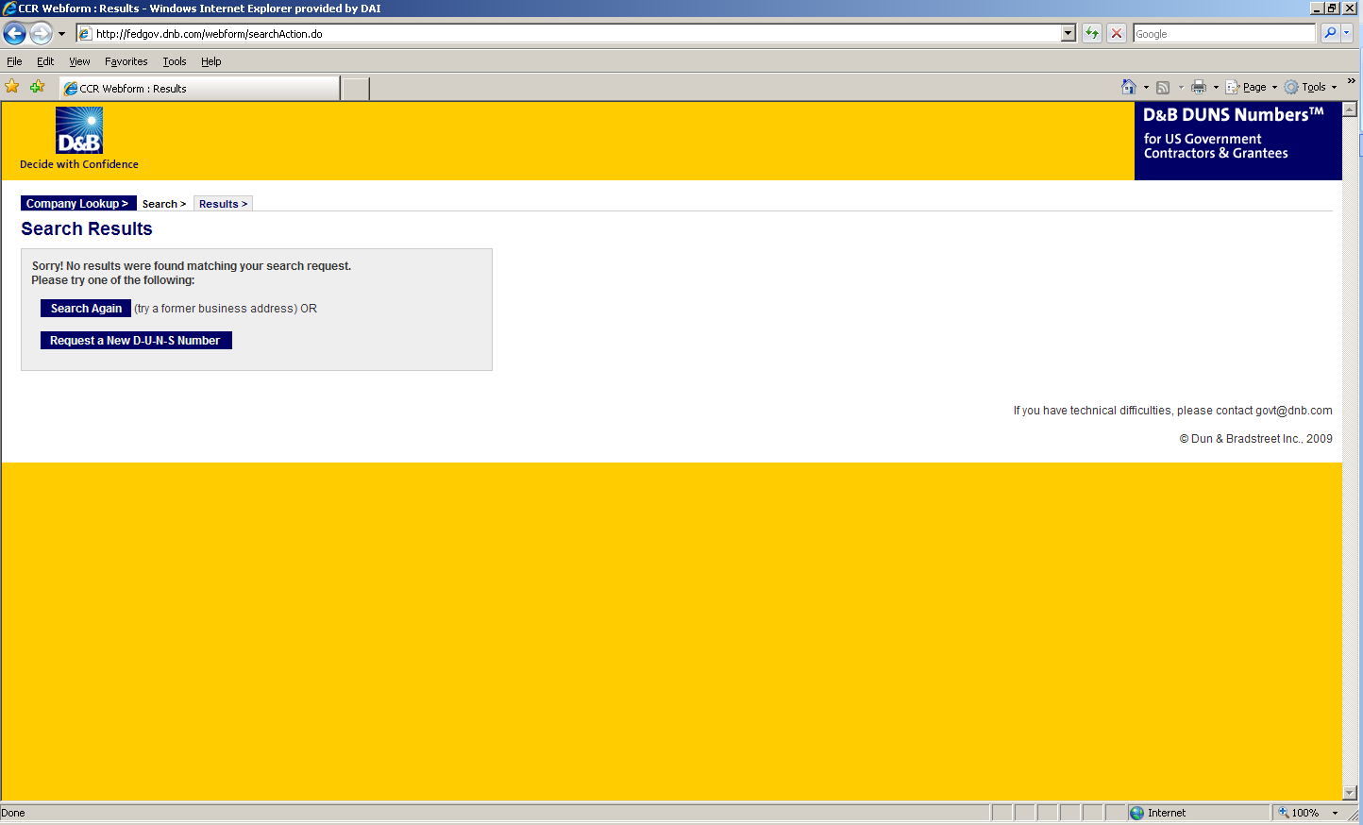

1. Enter the information regarding your organization listed on the next three screens. (See screen shots below.) Make sure you have the following information available (in English) prior to beginning the process of entering this section in order to ensure successful registration.

* Legal Business Name (commas are allowed, periods are not allowed)
* Address
* Phone
* Name of Owner/Executive
* Total Number of Employees
* Annual Sales or Revenue (US Dollar equivalent)
* Description of Operations

1. Note that some fields are Optional, however all other fields must be completed to proceed further with the application process. For example, all applicants must complete the Organization Information sections. The Company Name and Physical Address fields are self-populated based on information previously entered during the initial DUNS search. The question marks to the left of the field provide additional information when you click on them.

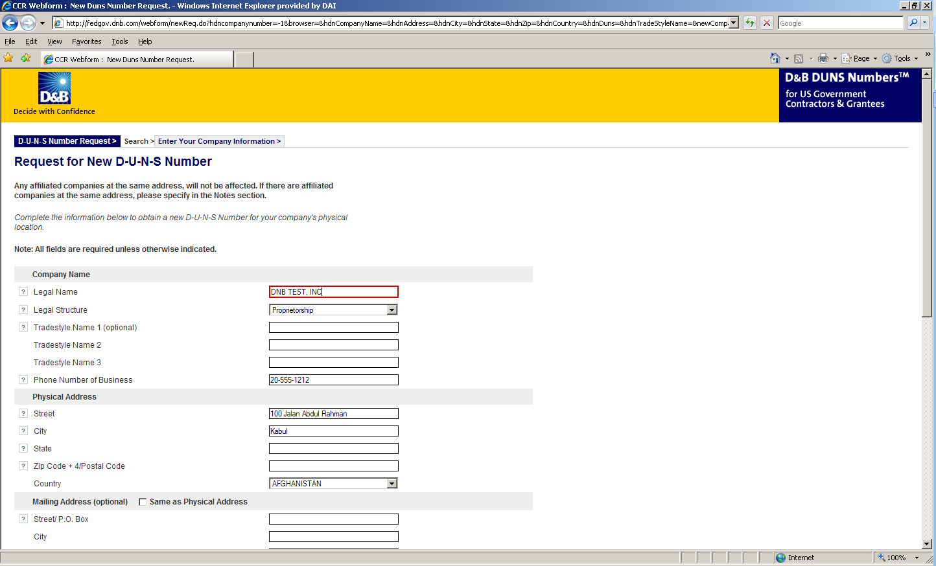

1. You must select the legal structure of your organization from the pull down menu. To assist you in selecting the appropriate structure that best represents your organization, a brief description of the various types follows:

* **Corporation –** A firm that meets certain legal requirements to be chartered by the state/province in which it is headquartered by the filing of articles of incorporation. A corporation is considered by law to be an entity separate and distinct from its owners. It can be taxed; it can be sued; it can enter into contractual agreements.
* **Government** - central, province/state, district, municipal and other U.S. or local government entities. Includes universities, schools and vocational centers owned and operated by the government.
* **Limited Liability Company (LLC) -** This is a type of business ownership combining several features of corporation and partnership structures. It is designed to provide the limited liability features of a corporation and the tax efficiencies and operational flexibility of a partnership. Its owners have limited personal liability for the LLC’s debts and obligations, similar to the status of shareholders in a corporation. If your firm is an LLC, this will be noted on the organizations registration and licensing documents.
* **Non-profit -** An entity which exists for charitable reasons and is not conducted or maintained for the purpose of making a profit. Any [money](http://www.investorwords.com/3100/money.html) earned must be retained by the organization, and used for its [own](http://www.investorwords.com/3563/own.html) [expenses](http://www.investorwords.com/1842/expense.html), [operations](http://www.investorwords.com/3467/operation.html), and [programs](http://www.investorwords.com/3890/program.html). Most organizations which are registered in the host country as a non-governmental organization (NGO) rather than as a commercial business are anon-profit entities.

**Community based organizations, trade associations, community development councils, and similar entities which are not organized as a profit making organization should select this status, even if your organization is not registered formally in country as an NGO.**

* **Partnership-** a legal form of operation in which two or more individuals carry on a continuing business for profit as co-owners. The profits and losses are shared proportionally*.*
* **Proprietorship**-These firms are owned by one person, usually the individual who has day-to-day responsibility for running the business. Sole proprietors own all the assets of the business and the profits generated by it.

1. One of the most important fields that must be filled in is the Primary SIC code field. (See screen shot below.) The Primary Standard Industrial Code classifies the business’ most relevant industry and function.

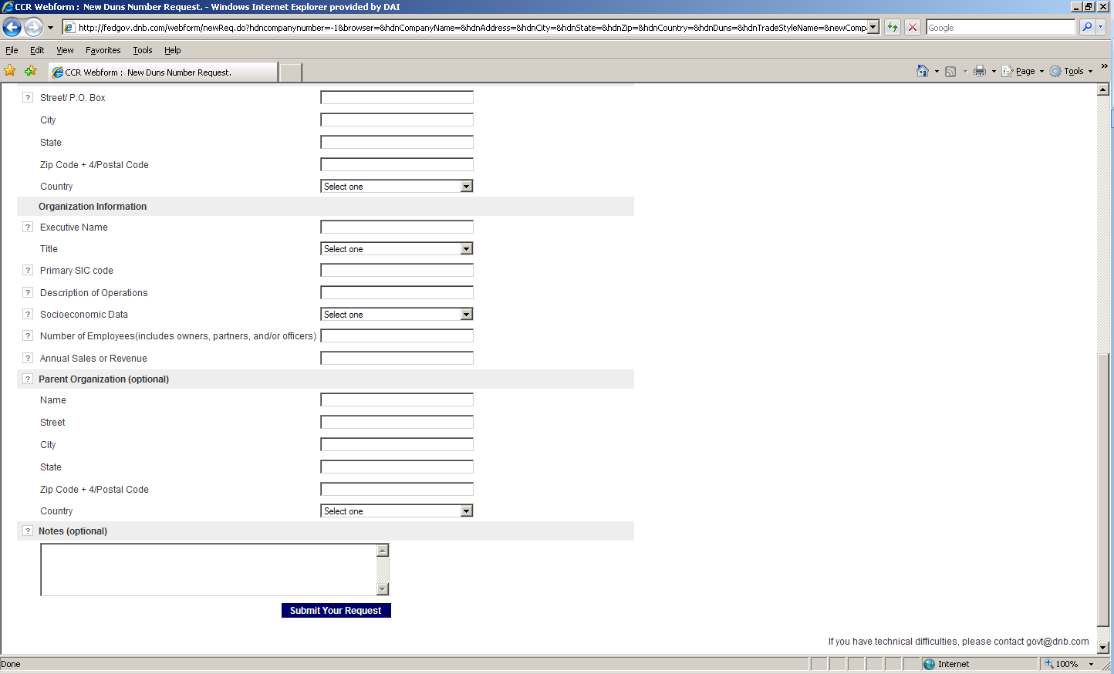

1. If you are unsure of which SIC Code your organization’s core business falls under, please refer to the following website: <http://www.osha.gov/oshstats/sicser.html>

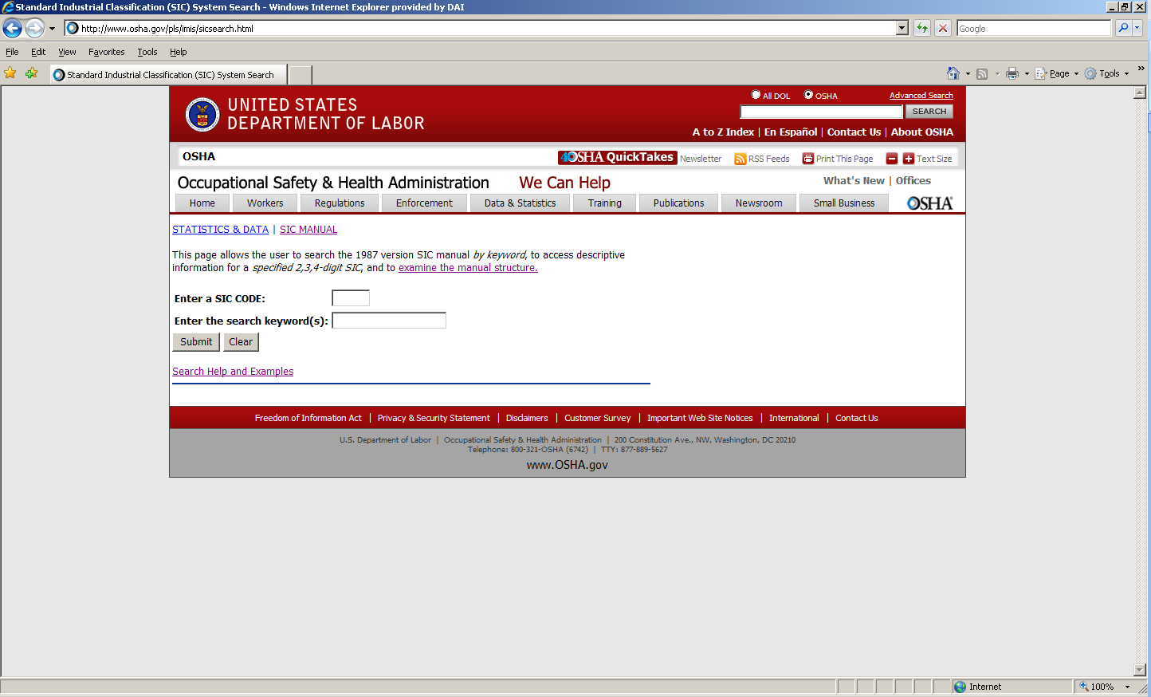

You will need to enter certain keywords to bring up the potential SIC Codes. In the case above, “Research” was entered as the keyword, and resulted in the following:

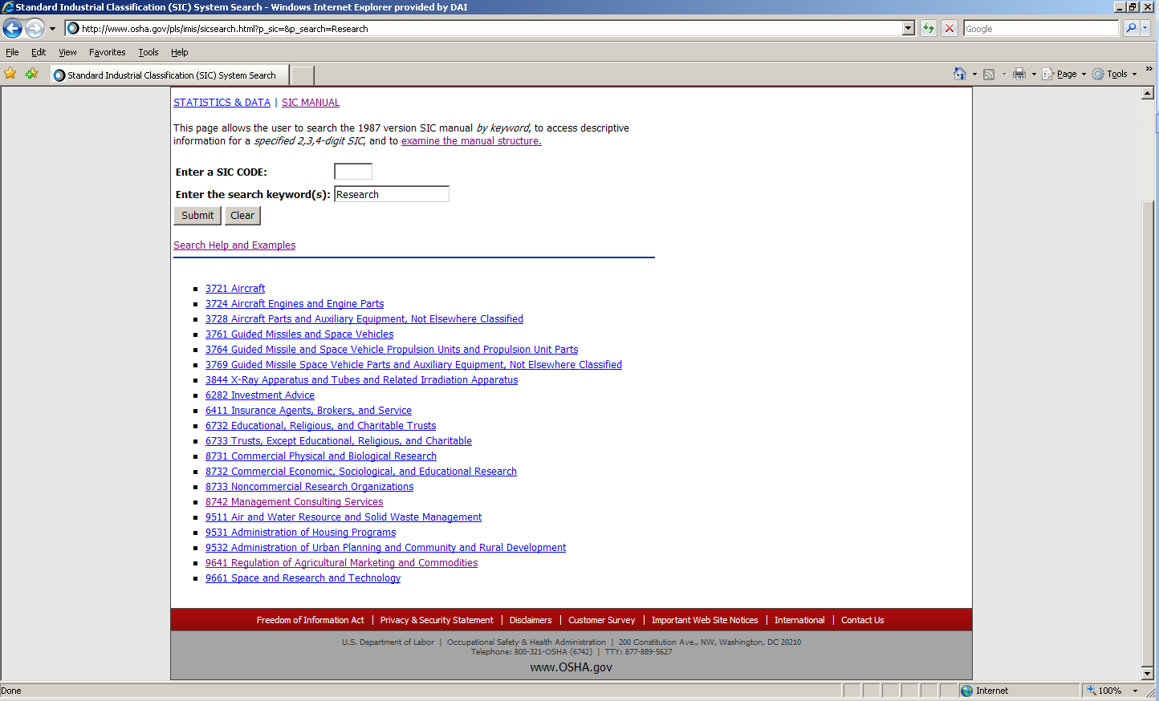

PLEASE NOTE: Many of the DAI subcontractors and grantees fall under one of the following SIC codes:

**8742** Management Consulting Services

1542 General Contractors-Nonresidential Buildings, Other than Industrial Buildings and Warehouses or one of the codes within:

|  |
| --- |
| Industry Group 357: Computer And Office Equipment  Industry Group 355: Special Industry Machinery, Except Metalworking  Industry Group 356: General Industrial Machinery And Equipment  Industry Group 359: Miscellaneous Industrial And Commercial |

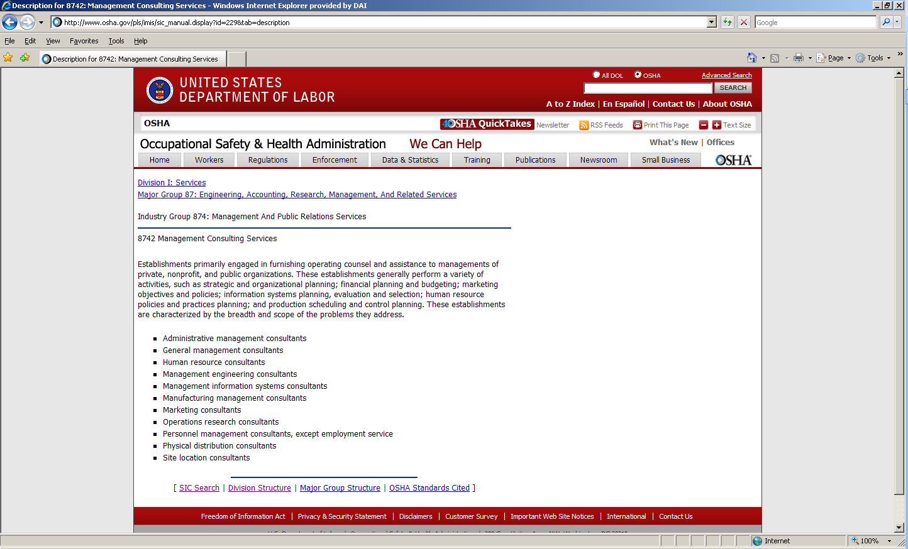

1. Description of Operations- Enter a brief description of the primary services you provide the example below, “agricultural technical assistance” was chosen as the primary function of the business.

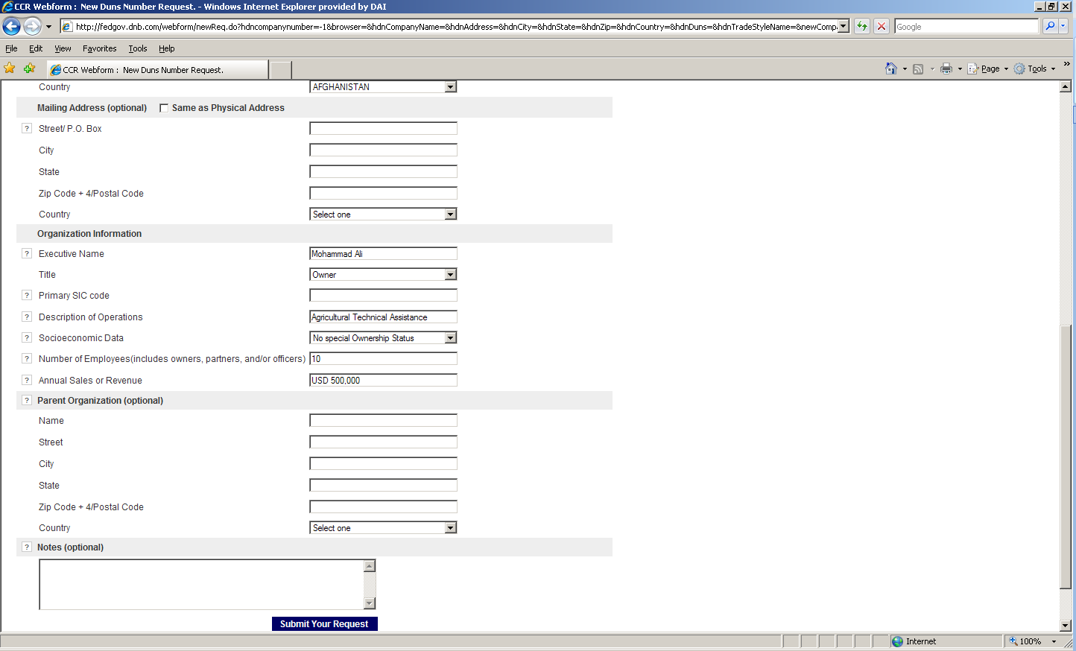

1. The Annual Sales or Revenue figure should be provided in USD (US Dollar) equivalent.
2. Once all of the fields have been completed, click on “Submit Your Request” to be taken to the Verification page.
3. Note: Representative (Principal, Owner or Officer) needs to verify and provide affirmation regarding the accuracy of the data under criminal or civil penalties as per Title 18, Section 1001 of the US Criminal Code.
4. Once “Yes, Continue” button is clicked, the registration application is sent to D&B, and a DUNS number should be available within 24-48 hours. DUNS database can be checked in 24-48 hours by entering the Business Information in the Search window – which should now display a valid result with the new DUNS number for the entity.

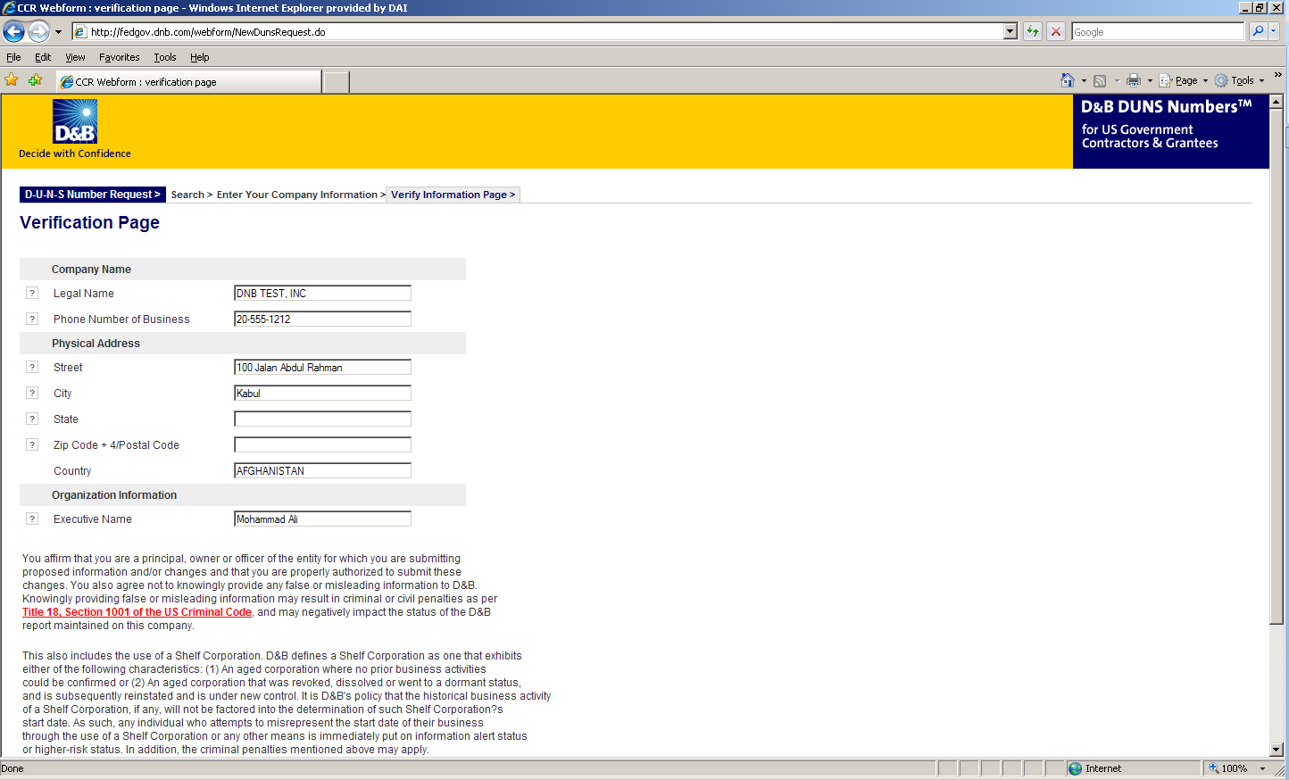

## Attachment E: Self Certification for Exemption from DUNS Requirement

**Self-Certification for Exemption from DUNS Requirement**

**For Subcontractors and Vendors**

|  |  |
| --- | --- |
| Legal Business Name: |  |
| Physical Address: |  |
| Physical City: |  |
| Physical Foreign Province (if applicable): |  |
| Physical Country: |  |
| Signature of Certifier |  |
| Full Name of Certifier (Last Name, First/Middle Names): |  |
| Title of Certifier: |  |
| Date of Certification (mm/dd/yyyy): |  |

The sub-contractor/vendor whose legal business name is provided herein, certifies that we are an organization exempt from obtaining a DUNS number, as the gross income received from all sources in the previous tax year is under USD $300,000.

*By submitting this certification, the certifier attests to the accuracy of the representations and certifications contained herein. The certifier understands that s/he and/or the sub-contractor/vendor may be subject to penalties, if s/he misrepresents the sub-contractor/vendor in any of the representations or certifications to the Prime Contractor and/or the US Government.

The sub-contractor/vendor agrees to allow the Prime Contractor and/or the US Government to verify the company name, physical address, or other information provided herein. Certification validity is for one year from the date of certification.

## Attachment F: Past Performance Form

Include projects that best illustrate your work experience relevant to this RFP, sorted by decreasing order of completion date.

Projects should have been undertaken in the past three years. Projects undertaken in the past six years may be taken into consideration at the discretion of the evaluation committee.

|  |  |  |  |  |  |  |  |  |  |
| --- | --- | --- | --- | --- | --- | --- | --- | --- | --- |
| # | Project Title | Description of Activities | Location  Province/  District | Client  Name/Tel No | Cost in US$ | Start-End  Dates | Completed on schedule  (Yes/No) | Completion Letter Received?  (Yes/No) | Type of Agreement, Subcontract, Grant, PO (fixed price, cost reimbursable) |
| 1 |  |  |  |  |  |  |  |  |  |
| 2 |  |  |  |  |  |  |  |  |  |
| 3 |  |  |  |  |  |  |  |  |  |
| 4 |  |  |  |  |  |  |  |  |  |
| 5 |  |  |  |  |  |  |  |  |  |

## Attachment G: Representations and Certifications of Compliance

1. Federal Excluded Parties List - The Bidder Select is not presently debarred, suspended, or determined ineligible for an award of a contract by any Federal agency.
2. Executive Compensation Certification- FAR 52.204-10 requires DAI, as prime contractor of U.S. federal government contracts, to report compensation levels of the five most highly compensated subcontractor executives to the Federal Funding Accountability and Transparency Act Sub-Award Report System (FSRS)
3. Executive Order on Terrorism Financing- The Contractor is reminded that U.S. Executive Orders and U.S. law prohibits transactions with, and the provision of resources and support to, individuals and organizations associated with terrorism. It is the legal responsibility of the Contractor/Recipient to ensure compliance with these Executive Orders and laws. Recipients may not engage with, or provide resources or support to, individuals and organizations associated with terrorism. No support or resources may be provided to individuals or entities that appear on the Specially Designated Nationals and Blocked persons List maintained by the US Treasury (online at [www.SAM.gov](http://www.SAM.gov)) or the United Nations Security Designation List (online at: http://www.un.org/sc/committees/1267/aq_sanctions_list.shtml). This provision must be included in all subcontracts/sub awards issued under this Contract.
4. Trafficking of Persons – The Contractor may not traffic in persons (as defined in the Protocol to Prevent, Suppress, and Punish Trafficking of persons, especially Women and Children, supplementing the UN Convention against Transnational Organized Crime), procure commercial sex, and use forced labor during the period of this award.
5. Certification and Disclosure Regarding Payment to Influence Certain Federal Transactions – The Bidder certifies that it currently is and will remain in compliance with FAR 52.203-11, Certification and Disclosure Regarding Payment to Influence Certain Federal Transactions.
6. Organizational Conflict of Interest – The Bidder certifies that will comply FAR Part 9.5, Organizational Conflict of Interest. The Bidder certifies that is not aware of any information bearing on the existence of any potential organizational conflict of interest. The Bidder further certifies that if the Bidder becomes aware of information bearing on whether a potential conflict may exist, that Bidder shall immediately provide DAII with a disclosure statement describing this information.
7. Prohibition of Segregated Facilities - The Bidder certifies that it is compliant with FAR 52.222-21, Prohibition of Segregated Facilities.
8. Equal Opportunity – The Bidder certifies that it does not discriminate against any employee or applicant for employment because of age, sex, religion, handicap, race, creed, color or national origin.
9. Labor Laws – The Bidder certifies that it is in compliance with all labor laws.
10. Federal Acquisition Regulation (FAR) – The Bidder certifies that it is familiar with the Federal Acquisition Regulation (FAR) and is in not in violation of any certifications required in the applicable clauses of the FAR, including but not limited to certifications regarding lobbying, kickbacks, equal employment opportunity, affirmation action, and payments to influence Federal transactions.
11. Employee Compliance – The Bidder warrants that it will require all employees, entities and individuals providing services in connection with the performance of an DAI Purchase Order to comply with the provisions of the resulting Purchase Order and with all Federal, State, and local laws and regulations in connection with the work associated therein.

By submitting a proposal, offerors agree to fully comply with the terms and conditions above and all applicable U.S. federal government clauses included herein, and will be asked to sign these Representations and Certifications upon award.

## Attachment J: Proposal Checklist

**Offeror: __________________________________________________________________**

**Does the bid include the following?**

Technical proposal, as per RFP’s requirements

Completed Price Schedule, as per RFP’s requirements

Bid Submission within the due deadline

**………………………………………………………………………………………………………………………………………………**

**Bidders Questions and Answers**

1. Do you have a specific level of interest (i.e. working days) and/or overall budget in mind?

Answer: The scope of work provides guidance and describes the purpose, objectives and expected deliverables of the work. No budget is provided.

1. Could you share the questions raised and answers provided by DAI from other interested parties?

Answer: Yes, through the channels used for tender advert

1. Could you share the attachments to be submitted in Word format?

Answer: Follow the RFP

1. Given the current travel restrictions, what is your expectancy on local presence during the assignment?

Answer: During the assignment it is a requirement to have at least one person at the field.

1. I would like to understand well what you mean by MFI

Answer: MFI stands for Micro Finance Institution. Regarding the name of the MFI, we opted to keep it confidential.

1. Can firms/bidders subscribe to DAI for future tenders? Or any amendments to the RFP?

Answer: No. For amendments of the RFP, we communicate through the channels used for tender advert

1. Are the bidders Address; code; required?

Answers: Not required but necessary for future contacts. However, with exception of international firms, the local firms we assume are registered with Rwanda Development Board (RDB) and Rwanda Revenue Authority (RRA).

**-end of RFP**