REFUBLIC OF RWANDA



BIGHER EDUCATION COUNCIL

# BPA]îîIRGALI

PUBLIC ANNOUNCEMENT

CBINA - GOYERNEMENT OF RWANDA SCHOLARSHIPS

The Higher Education Council (HEC) wishes to inform the general public that through the Bilateral Cooperation between the Government of Rwanda and the Peoples’ Republic of China, the latter has offered to the Government of Rwanda 10 (ten) full scholarships (2 undergraduate scholarships and 8 scholarships for Masters/PhD levels), commencing in the academic year 2021-2022.

Interested candidates should submit all of the following application documents:

* Application letter addressed to the Executive Director of HEC;
* Copy ofvalid Passport;
* Curriculum Vitae;
* One (1) recent passport size photo;
* Original-notified degree certificats and transcripts;
* Recommandation letters from two current or former academic staff who taught or supervised the applicant;
* A study plan or research proposal (minimum of 200 words for undergraduate and 800 words for Masters and PhD);
* Filled forms for Chinese Government Scholarships and Medical Physical Examination (available on

HECwebsiM)

Pbss&mote:

* The above mentioned application documents will be submitted online to HECMIS using

the Link: htto://mis.hee.pov.n•/svstcm-lo«in:

* The applicant must be under 25 years of age for undergraduate studies, under 35 for Masters, under 40 for PhD level at the time of application;
* Candidates must have studied in Sciences, Technology, Engineering and Mathematics (STEM) related fields with at least: i) 70/73 in the 2019 Senior Six National Examinations or the equivalent for qua1ific:ations obtained abroad; ii) 2n Class Up]3CT Division ot

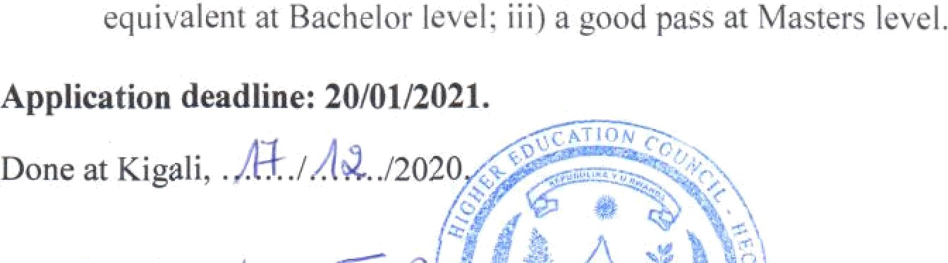

Dr. Roee MUKANK Executive Director

*

 

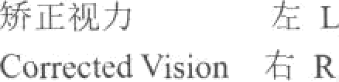

FOREIGNER PHYSICAL EXAMINATION FORM

|  |  |  |  |  |  |  |  |  |  |  |
| --- | --- | --- | --- | --- | --- | --- | --- | --- | --- | --- |
| ira  **Name** | | @8î  Sex | | O Male  OA Femme | | | M U B R  Birth Day-Month-Year |  | | Phuto  (Stamped Officiel  Stamp) |
| Present mailing address | | |  | | | | | Blood type | |
| Nationality  (or Area) |  | | Birth Pldee | | |  | |  | |
| fi e Tit A i : ‹ ñ Ji “ fi ” fi " ”)  Have you ever had any of the tollowing diseases?  (Each item must be answered “Yes” or “No”)  & ib fi Typhus fever ONo OYes Bacillaiy dysentery ONo OYes  *^)•* Ib & fi Poliomyelitis ONo O Yes D H Brucellosis ONo O Yes  B W Diphtheria ONo DYes ifi 'J & Viral hepatitis ONo ŒYes  iT fi Scarlet fever DNo OYes r U Puerperal streptococcus  *O° J3 @.* Relapsing fever DNo O Yes infection DNo OYes ONo OYes  R E CO (fi ÎH & Typhoid and paratyphoid fever ONo OYes | | | | | | | | | | |
| Do you have any of the following diseases or disorders endangering the public order and security? (Each item must be answered “Yes” or “No”)  Toxicomania. .. . ... . . . . .. . . . . . .. . . .. . ... . .. . ., . . ... ONo DYes  Mental confusion... ... . . . ... . .. ., ,.. ... ... ... . ... ONo OYes  RR U Manic Paychosis. .. . .. . . . . . .. . . . . . .. .... ONo OYes  Psychosis ,@ Paranoid PSycliosis. . . ...... . ... . .. . . . . . ONo OYes  19 @ Hallucinatory Psychosis. . .. . .. . .. . .. . . ONo OYes | | | | | | | | | | |
| cm | | | | | Weight | | | | Blood pressure mnJ4g | |
| Development | | | | | Nourishment | | | | Neck | |
| l L  **VÎSÎOI1** LR | | | | |  | | | | Eyes | |
| Colour sense | | | | | Skin | | | | Lymph nodcs | |
| Exs | | | | | Noce | | | | Tonsils | |
|  | | | | | Lungs | | | | Abdomen | |

Thank you for using [www.freepdfconvert.com](http://www.freepdfconvert.com/) service!

Only two pages are converted. Please Sign Up to convert all pages. <https://www.freepdfconvert.com/membership>